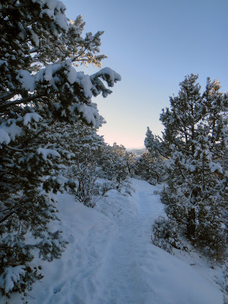
Training Details
- 15 Week Training Program
- Training begins the week of Oct 21st (first weeks schedule posted on front page of website)
- FIRST MEETING – Wed Oct 23rd
- Session Finishes – Sun Feb 2nd
- There will be 2 Training Groups BASED on MEETING times: morning and evening with all abilities welcome
  - evening meets Wed @ 5:30 pm and Sat @ 7:30 am
  - morning meets Wed @ 6:30 am and Sat @ 7:30 am
- Train with other Boulder Strider Members at your goal pace in a non-intimidating atmosphere
- Bring a New Friend to join the Winter Session…$50 discount for you and $25 discount for them
Boulder Striders’ Program Rates
Early Bird Special  Pay by Oct 26th | $300  $275 | twice/week - 15 weeks of twice a week training  once/week – 15 weeks of once a week training
Regular Price  Starts Oct 27th | $325  $300 | twice/week - 15 weeks of twice a week training  once/week – 15 weeks of once a week training
MAKE CHECKS PAYABLE TO: BOULDER STRIDERS
OR CREDIT CARD...ADD $12 TO THE PROGRAM RATE
Please Print & Mail Registration (postmarked Oct 26th to get early bird) to:
Boulder Striders, 4162 Saint Croix St, Boulder, CO 80301 OR Bring to Training by Oct 26th
2019-20 Fall/Winter Registration Form
Last Name |  |  |  |  | First Name
Address
City |  |  |  | State |  |  |  |  |  | Zip
DOB |  |  | Email
Day Phone
 | Evening: Wed/Sat (5:30 pm /7:30 am ) |  |  |  |  |  | Morning: Wed/Sat (6:30 am / 7:30 am )

By signing this Registration Form, I do not hold Colleen De Reuck, Boulder Striders or any of the Coaches liable for injury to myself during the 15 week training. One Form per Member…Photocopies are good.

Signature: __________________________________________

